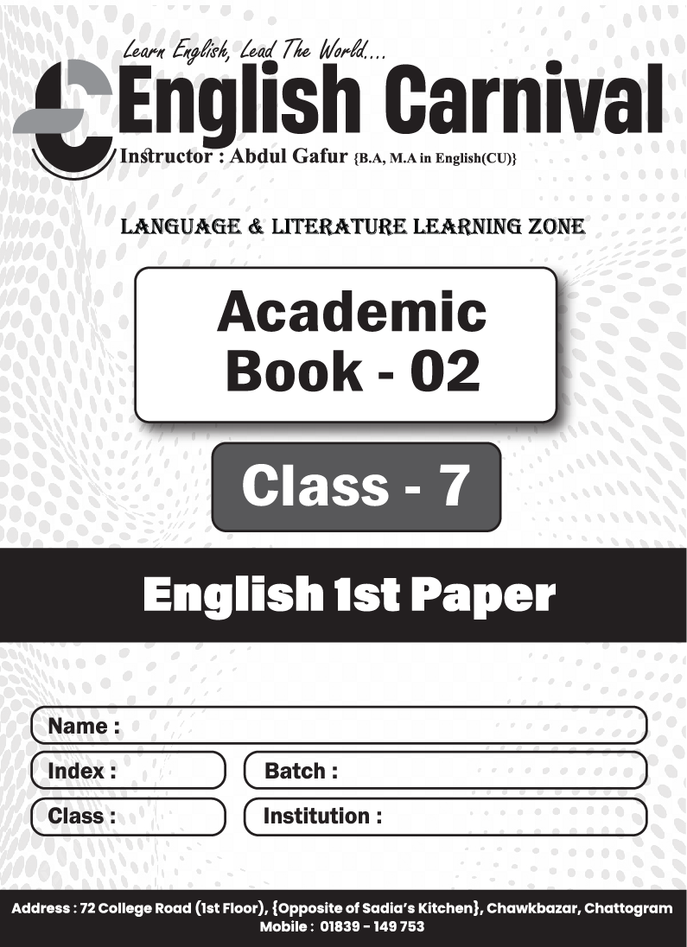

Model Test-01
Part-A : Grammar (Marks-30)
- Fill in the blanks with the words from the box. You may need to change the form of the words. You may need to use one word more than once. 0.5  10 = 5
the | in | to | every | inherent | or | a | must | patriot
Patriotism is a noble virtue. It is an (a)___ instinct in human nature. It inspires a man to shed (b)___ drop of blood (c)___ defend the liberty and dignity of the country. But patriotism should not be merely (d) ___ so-called slogan in the public meeting (e)___ fraud the people. It should be remembered is (f)___ core of heat and materialized (g)___ our deeds. We should keep ourselves above from the fake (h)___ Everybody should bear in mind that a pretender (i)___ be defeated. Nobody will remember (j)___ honour a mock patriot,
Or, Smoking is (a)___ extremely bad habit. Those who are addicted (b)____ smoking fall (c)____ different types of problems. They suffer from (d)___ deadly diseases. Besides, by smoking they waste money (e)___ large scale. So, the smokers should give up (f)___ bad habit. They should do it for their own health and future. Otherwise, their life will be nothing but (g)___ waste. The smokers should also keep (h)___ mind that they are creating hazard for the (i)___ while they smoke in front of them. They should get rid (j)___ this selfish act.
- Make five sentences using parts of sentences from each column of the table below. 1  5 = 5
Happiness | may  is  varies | not be happy.
A person with a crown | may  is  varies | a relative term.
Whereas a day labourer | may  is  varies | from person to person.
Again, happiness | may  is  varies | a blessing of God.
Complete happiness or peace of mind | may  is  varies | find happiness living in a shabby hut.
- Fill in the gaps with the right forms of verbs in the brackets. 1 × 5 = 5
A school magazine (a)___ (play) an important role in school life. It is different from other regular journals. Our school magazine is (b)___ (publish) in English language. The editor of the magazine is a student who (c)___(act) under the supervision of a teacher. The magazine (d)___ (introduce) the writers who (e)____(find) opportunity to express their thoughts and ideas.
- Change the narrative style of the following sentences. 1 × 5 = 5
- He says to me, “You’re a lucky person.”
- The boy said, “I read about Abu Sayeed’s contributions to anti-discrimination movement last night.”
- The teacher said to me, “Have you ever visited the historic city of Paharpur?”
- The teacher said, “Please write about the struggle for independence in Bangladesh.”
- The man said, “I am going to attend a wedding ceremony in my village.”
- Read the following text and change the sentences directed. 1 × 5 = 5
(a) A day labourer is known to everyone. (Make it active) He lives with his family in a slum. (b) He is not lazy and apathetic. (Make it affirmative) (c) He is always dependent on his employer. (Make it negative) His service is very important. But (d) he is neglected in the society. (Make it interrogative) (e) Let's be respectful to day labourers. (Make it assertive)
- Use appropriate punctuation marks and capital letters where necessary. 5
can you tell me why I have come to see you today it is not what you are thinking i have come here to say hello by the way do you know where Alif lives now
Part-B : Writing (Marks-20)
- Learning English helps one to reach the definite goal of success. Suppose, your friend is not willing enough to learn this language properly. Now, write a letter to your friend telling him about the usefulness of learning English. 8
- Write a short composition on 'Physical Exercise' in about 250 words. 12
Model Test-02
Part-A : Grammar (Marks-30)
- Fill in the blanks with the words from the box. You may need to change the form of the words. You may need to use one word more than once. 0.5  10 = 5
in | the | preservation | a | grow | out | for | from
Students should observe (a)___ laws of health. They should rise (b)___ the bed early (c)___ the morning and go (d)___ for (e) walk. Besides these, they should take care to perform all those things which are useful for the (f)___ of health. They should take part in games and sports regularly. These are essential (g___ their physical and mental (h)___. They should also follow (i)____ rules of health because health is (j)___ root of all happiness.
Or, Fill in the blanks with suitable words.
Today man has been suffering (a)___ various diseases. But there is no remedy for some (b)___ diseases. So human beings are subject (c)___ decay and death. One day, he will depart (d)___ this world. Here he cannot live for (e)____ long time. But he can live in (f)___ memory of people through his (g)____. Therefore, we should do things (h)___ our life which will remain unforgettable. We may not (i)___ in the world in flesh and blood for ever but we can surely stay in the minds of people (j)____ our works.
- Make five sentences using parts of sentences from each column of the table below. 1  5 = 5
Bangladesh |  | considerably during the medieval period.
Its deeply rooted heritage | developed | here in harmony.
People of different religions | be | had a great influence on its culture and history.
The people of Bangladesh | live | thoroughly reflected in its architecture, literature and music.
Bangla literature | has | a rich, diverse culture.
- Complete the following text with suitable verbs in the box with their right form. 1  5 = 5
respect | see | try | mix | find
A man who is honest, always stays away from corruption. He does not (a)___ with the corrupt people. He always (b)___ to be honest and frank. He is never (c)____ doing any illegal activities. He (d)____ pleasure in doing noble activities. He is not running after wealth. So, he is honoured and (e)____ by all.
- Change the narrative style of the following sentences. 1 × 5 = 5
- The girl said, "The July Revolution had a huge impact on the political stability of Bangladesh."
- The boy said, "Hurray! Our team won the match."
- Rabi said to Chabi, "Why do you always think about the bad side of things?"
- The Headmaster said to the students, "Do not tell a lie".
- Mother says to me, "The sun rises in the east and sets in the west."
- Read the following text and change the sentences directed. 1 × 5 = 5
(a) Patriotism is not a trivial virtue. (Affirmative) (b) Everyone should possess this noble quality (Optative) (c) An unpatriotic man is hated by all. (Active) What a noble quality patriotism is! (d) Everybody hates an unpatriotic man. (Interrogative) (e) He should respect his country. (Imperative)
- Use appropriate punctuation marks and capital letters where necessary. 5
what a beautiful bird it is do you know which bird is it I would like to take a picture of it where is my camera give it to me please
Part-B : Writing (Marks-20)
- Suppose, you are Tanzia Ismail. Write an email to the Manager of Rangs Bangladesh complaining about a TV set you have bought recently. 8
- Write a short composition on ‘A Journey by Boat’ in about 250 words. 12

Model Test-03
Part-A : Grammar (Marks-30)
- Fill in the blanks with the words from the box. You may need to change the form of the words. You may need to use one word more than once. 0.5  10 = 5
of | the | that | for | sell | or | into | a | adulteration
The issue of food (a)____ has drawn the attention (b)____ general public. We hardly find (c)____ single food in our country (d)____ is not adulterated in one way (e)____ other. At present, substandard foods are (f)____in most of (g)____ hotels. Very recently government has directed (h)____ mobile court to look (i)____ the horrible pictures of adulteration. They are catching dishonest hoteliers red handed (j)____ using unhygienic food ingredients.
Or, Fill in the blanks with suitable words.
Man cannot live (a)___ food. (b)___ fact, no living things, animals or (c)___ can survive without food. The collection (d)___ food was man's first job. He made his first weapons in order (e)___ hunt animals for food. Gradually, he learnt how (f)___ grow plants. Thus he invented (g)____ and settled in communities (h)____ his cornfields. Today, men are engaged (i) food adulteration. When you eat (j)____ outside food, you are not sure whether you are eating a food or a poison.
- Make five sentences using parts of sentences from each column of the table below. 1  5 = 5
Refugee crisis | be | the values of global community.
Migrants from Middle-East, Africa and Asia | can reduce | responsible for this problem.
Vast provety, political conflict etc | undertake | a burning question at present world
The photograph of a drowning child named Aynal | becomes | this problem
Sustainable development and global peace | stirred | as risky journey by sea for a safe adobe.
- Complete the following text with suitable verbs in the box with their right form. 1 × 5 = 5
Good students (a)____(‘disobey’ in the negative) their parents and teachers. They are gentle. They (b)____ (attend) classes regularly. They do not (c)____ (put) off their lessons for tomorrow. They have a daily routine and (d)____ (prepare) their lessons accordingly. As they read throughout the year, they can do well in the examination. They do not forget what the great men (e)____ ('do' expressing habit) in their life.
- Change the narrative style of the following sentences. 1 × 5 = 5
- He said, "Good afternoon! How have you been?"
- The boy says, "I will do the work tomorrow."
- The man said, "Can you lend me your pen?"
- The boy said, "I have completed my homework."
- The boy said, "Please open the window."
- Read the following text and change the sentences directed. 1 × 5 = 5
(a) Corruption is a curse for our nation. (Negative) (b) You should not support corruption. (Imperative) (c) It prevails in every walk of our life (Interrogative). It destroys everything. We fail to enjoy the real progress as corruption devours every good fruits of our efforts. (d) It can be compared to cancer. (Active) (e) It paralyzes the whole nation. (Passive) We must realize the fact and come forward against corruption.
- Use appropriate punctuation marks and capital letters where necessary. 5
do you like chocolate ice cream or anything else else i would like to have chotpoti I know a shop at bailey Road which is famous for Chotpoti would you like to have a taste of it
Part-B : Writing (Marks-20)
- Suppose, you are Nabin/Nabina. You have a friend named Joy/Joya. Now, write an e-mail to your friend wishing him/her 'Happy Birthday' 8
- Write a short composition on ‘Your First Day at School’ in about 250 words. 12

